LowRISC Processor Step-By-Step Breakdown

Introduction
LowRISC (Reduced Instruction Set Computer) is widely considered the simplest and most intuitive framework, informing the development of various entry-level processors, given its open-source and readily available nature. Below is a standard block diagram that demonstrates the necessary interconnections and relationships among sub-modules to achieve the functionality stipulated by the lowRISC framework.
Figure 1 – Prime example of a LowRISC-inspired microprocessor, derived from Harvard architectural laws.
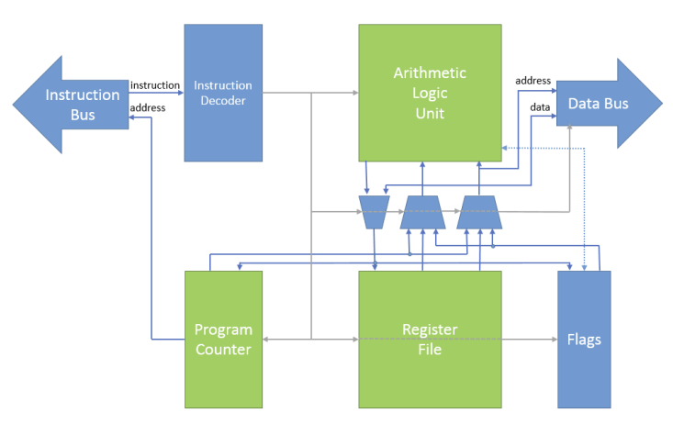

Each sub-module illustrated above will be explored in further detail, culminating in an exhaustive architectural breakdown of the configuration of such a processor in SystemVerilog.

Top-Level Data Pipeline Breakdown
Externally-facing dependencies and interfacing ensure a consistent and traceable propagation of data between the program memory block, constituting the instruction domain (illustrated by the ‘Instruction Bus’ in Figure 1); the VGA and data memory blocks; and the switch and LED ‘ports’ native to the FPGA; the latter two modules constitute the data domain (illustrated by the ‘Data Bus’ in Figure 1). Listed below is reflective commentary regarding the process by which a generic top-level RISC module could be composed.
- The processor is powered up and initiates the propagation of instructions from the program memory. This is represented by the module 'ProgramMemory', which serves as the plug-in to instantiate the ROM block .qip file.
Instead of pulling dozens of Verilog files into the project's working directory, the ROM block .qip acts as a single access point by listing all the necessary files.
‘Program.mif’ denotes the master file, containing a cascade of appropriately indexed instructions to drive standard High RISC operation. As an IP-generated memory block, a Quartus-native generation sequence was executed to output ‘RomBlock.v’, ‘RomBlock.qip’ and ‘Program.mif’, thus, the developer must refrain from manually modifying specific lines within these scripts.
Figure 2 – Configuration of the ‘ProgramMemory’ module. As the comments state, this module acts as a wrapper to hook up the IP memory block (‘Program.mif’) with the ‘Bus’ interface (explained later on).

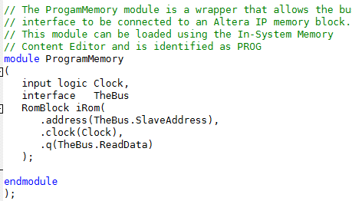

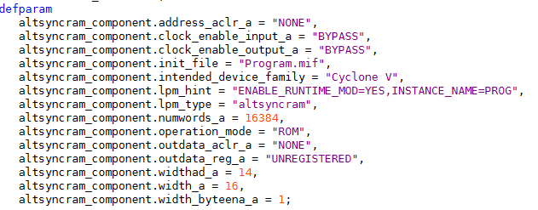
Figure 3 – Snippet from ‘RomBlock.qip’, specifying the necessary Verilog files to be linked to the project (namely ‘RomBlock.v’), all of which are auto-generated by the IP-generation wizard within Quartus.
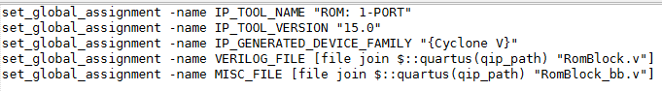
Figure 4 – Snippet from ‘RomBlock.v’; line 5 specifies the auto-generated IP memory block to initialise during the instantiation of this Verilog file (‘Program.mif’).

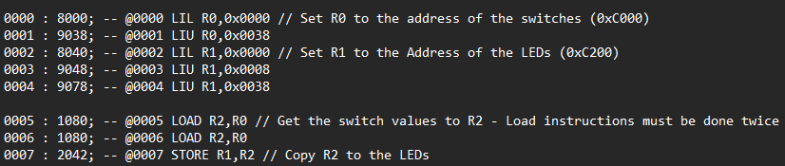
Figure 5 – Snippet from Program.mif, specifying the running order of instructions for a particular function.
Figure 5 demonstrates the inner structure of ‘Program.mif’. The first two terms prefixing the first semicolon, e.g. ‘0000: 8000;’, are machine-interpretable, i.e. are extracted from this memory block for subsequent decoding and conversion to assembly language, showcased by every term suffixing the semicolon, e.g. -- @0000 LIL R0,0x0000. The suffix is merely included for ease of reference and legibility by the user – instead of resorting to manually converting the second term from hex to binary to determine the opcode, registers, immediate values, etc, the user can simply navigate to the corresponding address and ascertain the exact mode of operation. Removing the suffixed terms will not affect the functionality and structure of this memory block.
As implied before, the first term, e.g. ‘0000’ from ‘0000 : 8000;’, represents the memory address native to ‘Program.mif’. The second term, e.g. ‘8000’ from ‘0000:8000;’, represents the contents of that specific memory address in hex format, which will eventually experience a conversion to binary, upon which it will be streamed via the ‘Ibus’ peripheral-to-master ‘ReadData’ output channel.

- Establishing connections between ‘Program.mif' peripheral and the master ‘CPU’ is conducted via the ‘Bus’ interface, which contains global, boilerplate code to define the characteristics of a slave/peripheral and a master.
Figure 6 – Connection definitions within the ‘Bus’ interface.

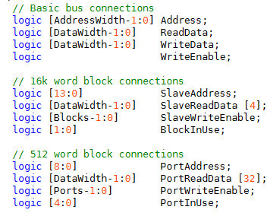

The top four bus connections define raw, unfiltered channels that are broadcast universally to every peripheral and master, regardless of whether certain modules disregard them.
The middle four bus connections represent channels that are processed/transformed by an intermediary stage to establish direct, isolated channels between intermediary stages and ‘blocks’ that contain roughly 16,000 unique memory addresses. Prime examples of such ‘blocks’ are ‘Program.mif’, ‘Data.mif’, and the inferred VGA memory; the latter two blocks will be discussed in further detail.
Similarly, the final four bus connections represent channels that are processed and transformed by intermediary stages, establishing distinct, isolated channels between intermediary stages and ‘ports’ that contain 512 unique memory addresses each. A maximum of 32 ports can be initialised, since 512 x 32 = 16384, which is approximately 16000 word lines. Thus, ports provide a reasonable compromise between compactness and available memory, particularly for more volatile, high-throughput devices that do not require large amounts of storage at a given point in time. Prime examples in the context of this project are the FPGA’s built-in switches and LEDs, which have no memory and therefore require only one memory address each.
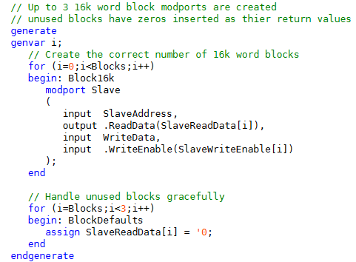
Figure 7 – Configuration of ‘slave blocks’ within the ‘bus’ interface.

The declaration of a ‘generate’ block hinges on the principles of scalability and efficiency. In the context of the ‘bus’ interface, the ‘generate’ block drives a ‘for’ loop that executes iterations equivalent to the ‘Blocks’ value dictated by the programmer. Repetitive logic to define the input and output ‘modports’ of ‘slave blocks’ is subsequently executed.
Note that a standard ‘for’ loop nested within an ‘always_comb’ block is ineffective in this scenario, since they are incapable of generating physical wires, ports, gates, and other forms of hardware at compile time; instead, they execute logic equation/s sequentially during runtime that modify inputs and outputs rather than the fundamental structure/architecture of blocks. Within a ‘generate’ block, however, the ‘for’ loop directly instantiates repeats of blocks to be embedded within the logic at compile time.
In addition, ‘modports’ serve as a tool to support distinct component ‘views’ hooked up to a common interface (‘bus’), dictating exactly what can and cannot be inputted/outputted, and assigning directions to a group of signals from various perspectives. ‘Slave’ inputs and outputs are defined as the polar opposite to ‘Master’ inputs and outputs, primarily to restrict the ability of either block type to write illegally/unexpectedly. ‘Slaves’, for example, do not possess the ability to trigger any write enables to the ‘Master’.
If the programmer decides to initialise fewer than 3 blocks per ‘bus’ instantiation, any remaining (unused) blocks between the ‘Block’ parameter value and ‘3 ’ are iterated through the second ‘for’ loop depicted in Figure 7. The ‘SlaveReadData’ output for each redundant block is pulled low by default, to ensure surrounding components and modules are unaffected entirely by unused blocks.
- ‘Ibus', which represents the instruction bus, is instantiated specifically to consist of 1 block, since the ‘Master’ CPU is fed exclusively to the ‘Program.mif’ slave block (Figure 9). The ‘1’ parameter is directly associated with the number of blocks, as indicated by Figure 10. This subsequently iterates the ‘for’ loop tied to ‘Block16k’ once, generating one ‘Slave’ in the process that is interfaced directly with ‘Program.mif’ as per Figure 8.

Figure 8 – Instantiation of the ‘ProgramMemory’ wrapper, containing the IP-generated ‘RomBlock.v’ tied to ‘Program.mif;’

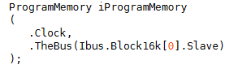

The inputs ‘SlaveAddress’ and ‘WriteData’ are universal channels terminated at every slave instantiated on ‘Ibus’; ‘SlaveAddress’ points the ‘Master’ towards a specific memory address within the ‘Slave’; ‘WriteData’ streams data directly from the ‘Master’ to every ‘Slave’.
An indexing framework, however, is employed on the ‘ReadData’ output and the ‘WriteEnable’ input. For ‘ReadData’, reads are streamed from individual blocks via their corresponding ‘SlaveReadData’ line, which is hardwired from the block’s read pin to an intermediate MUX. The index ‘i’ within the square brackets acts as the ‘select’ pin integrated within the MUX, to identify which ‘SlaveReadData’, i.e. block read, must be hooked to the MUX output ‘ReadData’. Conversely, a DEMUX between the ‘Master’ and corresponding ‘Slaves’ is incorporated in the context of ‘WriteEnable’, with a singular ‘WriteEnable’ line running from the ‘Master’ to the DEMUX as an input, the required ‘BlockInUse’ acting as the select input, to index the incoming ‘WriteEnable’ to the corresponding ‘Slave’, represented by individual ‘SlaveWriteEnable’ output lines hardwired to their corresponding ‘Slaves’. Note that, since these input and output channels are declared within a ‘for’ loop nested within a ‘generate’ block, these are hardwired to their corresponding origins and destinations alongside other hardware components at elaboration/compile time. Refer to Figure 7 for further insight.

Since one master and one slave exist on either end of the ‘Ibus’ interface, the DEMUX and MUX ratios are both 1:1. Although a case for both components to be scrapped altogether is valid, the power savings are marginal, coupled with the additional complexity to configure a distinct interface between the CPU and ‘Program.mif’. Instantiating ‘Bus’ for every required bus enhances traceability and scalability of modules.
Figure 9 – Instantiation of the Instruction and Data buses.
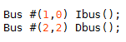

Figure 10 – Parameterisation of ‘Blocks’ and ‘Ports’, which can be overridden during instantiation.
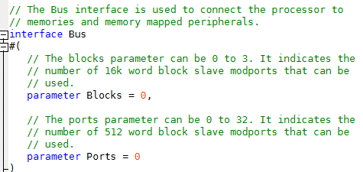

Figure 11 – Combinational block stipulating how slave reads and writes are computed.
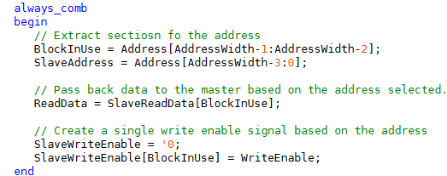

Figure 11 demonstrates how an ‘Address’ broadcast from the ‘Master’ is decoded appropriately by an intermediary instruction decoder (refer to the ‘Instruction Decoder’ block depicted within Figure 1). The ‘BlockInUse’ channel fed into the select pins of the ‘WriteEnable’ and ‘ReadData’ DEMUX and MUX, respectively, is extracted from the MSB and MSB - 1 slots of an incoming address driven from the Program Counter (PC) of the ‘Master’ (CPU). The remaining 14 bits are mapped to ‘SlaveAddress’, given 2¹⁴ = 16384 possible memory addresses within a given ‘slave’ (fulfils the >16000 address requirement).
The MUX logic for ‘ReadData’ is defined combinatorially by line 3 of Figure 11, whereby the ‘BlockInUse’ 2-bit binary value extracted from the incoming ‘Address’ is fed into the select pin of the MUX, to assign an outgoing data payload from a ‘slave’ via ‘SlaveReadData’ to the output ‘ReadData’.
Similarly, the DEMUX logic for ‘WriteEnable’ is defined combinatorially by lines 4 and 5 of Figure 11. To prevent individual ‘SlaveWriteEnable’ inputs from constantly pushing a high signal into their corresponding ‘slave blocks’, all of them are cleared by default, as indicated by line 4. Consequently, the computed ‘BlockInUse’ value is injected into the DEMUX select pin to ascertain which ‘SlaveWriteEnable’ channel must carry the high ‘WriteEnable’ signal to its corresponding ‘slave block’.
In the context of ‘Ibus’, assume that the PC outputs 1’d1 (sign-extended, so every bit except the LSB is low). Since ‘Ibus’ terminates at exclusively ‘Program.mif’, ‘BlockInUse’ serves no purpose, since the switching of blocks is not required. Thus, only the last 14 bits are utilised for further operations, namely extracting the ‘SlaveAddress’. Within the ‘ProgramMemory’ wrapper depicted in Figure 2, the ‘SlaveAddress’ is interfaced with the ‘address’ port of the ‘RomBlock’ (IP-generated). IP-native logic pulls the corresponding contents of ‘SlaveAddress’ within ‘Program.mif’ and outputs this via the ‘q’ port, which interfaces directly with ‘SlaveReadData[0]’ (although Figure 2 indicates interfacing with ‘ReadData’, this describes an end-to-end connection of the entire ‘Bus’ interface). Since ‘BlockInUse’ is constant in the instruction domain, ‘SlaveReadData[0] == SlaveReadData[BlockInUse]’ at all times; hence ‘ReadData == SlaveReadData[0]’. No ports for ‘WriteEnable’ or ‘WriteData’ exist; hence, these channels will remain disconnected from the Instruction domain.

- The ‘ReadData’ channel now contains a brand new instruction, as it crosses the CPU boundary. The CPU domain is represented by ‘HighRiscProcessor.sv’, which is instantiated within ‘HighRiscSystem’ as indicated in Figure 12.

Figure 12 – Instantiation of the ‘HighRiscProcessor’

As soon as ‘ReadData’ enters the CPU domain, it is plugged into the ‘InstructionDecoder’. The primary purpose of the decoder is to determine the Operation code (‘Opcode’), the source register and the destination register, all three of which are integrated within the 16-bit instruction payload. Conditional outputs are broadcast, depending on whether certain input flags are high or if a certain OpCode is extracted. Figure 13 demonstrates the instantiation of ‘InstructionDecoder’, and Figure 14 showcases the module input and output definition.
Figure 13 – Instantiation of ‘InstructionDecoder’.
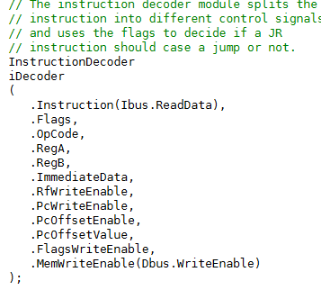

Figure 14 – Modular port definition of ‘InstructionDecoder’
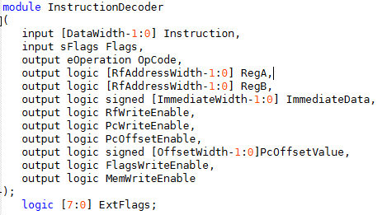

The reasoning behind coupling an incoming instruction with current flag states is to compute 32-bit logic. For example, if two 32-bit numbers are summed via an ADC operation, since the HighRiscProcessor is sized to compute a maximum of 16-bit logic at a given clock edge, a second clock edge and ‘ReadData’ input is required to target two more register files within the CPU. Therefore, the first clock evaluates the sum of the lower halves of both numbers (the first 16 bits); if a ‘1’ is carried after this operation, the ‘Carry’ flag is set high. The second clock edge will therefore evaluate the sum of the upper halves (last 16 bits), which must be stored in their own individual register files. If the ‘Carry’ flag is high, feeding the current states of all flags as inputs enables the ‘Carry’ to contribute to the sum of the upper halves, thereby computing a flawless sum.
The output ports depicted in Figure 14 play instrumental roles in transferring data efficiently through the data pipeline, and also provide critical flags for component activation, e.g., PC enables, register file enables, etc.
- ‘OpCode’ stores the necessary operation code, instantiated in text format via ‘eOperation’, to alert the ALU.
- ‘RegA’ contains the address for the ‘Destination’ register.
- ‘RegB’ contains the address for the ‘Source’ register.
- ‘ImmediateData’ concerns I-type instructions – a 6-bit value is loaded into the destination register file.
- ‘RfWriteEnable’ indicates that a payload is due to be written into any one of the 62 available register files.
- ‘PcWriteEnable’ indicates that a value is to be written directly to the PC. Note that this differs from a J-type instruction, which offsets the PC by the value specified within the ‘Offset’ field of an incoming payload. This enable is pulled high when the current PC value is replaced altogether by the value contained within the source register.
- ‘PcOffsetEnable’, as mentioned previously, is pulled high during the execution of a J-type instruction.
- ‘PcOffsetValue’ is the value in question, to be applied directly to the PC’s current value.
- ‘FlagsWriteEnable’ is pulled high when a flag is amended off the back of an operation being computed.
- ‘MemWriteEnable’ is pulled high exclusively to indicate the execution of a ‘STORE’ operation, whereby a value is written to a block/port terminated at the end of the data bus.
Decoding the instruction hinges on partitioning the ‘Opcode’, the destination register ‘RegA ’, and the source register ‘RegB’:
Figure 15 – Deciphering target register file indices, coupled with the operation code to manipulate the values stored within the target registers.

The variables depicted above, e.g. ‘OpcodeStart’, ‘RegBStart’, etc., are all imported from ‘InstructionSetPkg’, and initialised at the beginning of the script. In addition, the ‘+:’ operator denotes an intelligent indexing mechanism to select terms from the left-hand side term to the right-hand side term. For example, the first line in Figure 15 pulls out the bits housed between ‘OpCodeStart’ (12 in this instance) and ‘OpCodeStart + OpcodeSize’ (16 in this instance), hence bits 12 – 15 are selected. An incoming ‘Instruction’ subsequently returns the bit values within these indexes, denoting the ‘OpCode’ in binary format. Finally, the ‘OpCode’ is converted into text format via casting (signified by the apostrophe) into the ‘eOperation’ enumerator defined within ‘InstructionSetPkg’.
Similarly, an indexed part-select operator (+:) is applied to extract the destination register (RegA) and the source register (RegB). Again, constants for the index start and the width are imported from ‘InstructionSetPkg’.
Figure 16 – Further combinational logic to identify special operation codes.
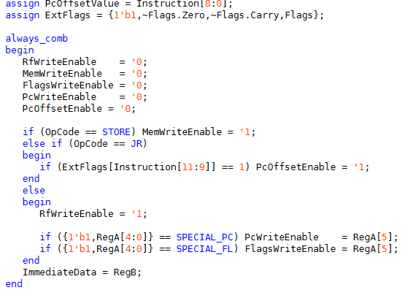

Assume that an incoming instruction from the ‘ReadData’ channel is a J-type. According to the bitmap for this instruction type, the maximum bit size is 9 bits; hence, ‘PcOffsetValue’ is assigned to the first 9 bits of the instruction. Furthermore, the activation of any flags may trigger a PC offset; hence, the 8-bit ‘ExtFlags’ is assigned to a concatenation of the ‘Always’ flag, NZ, NC, O, P, N, Z and C:
Table 1 – Bit map of ‘ExtFlags’.
Bit position | 7 | 6 | 5 | 4 |  | 3 | 2 | 1 |  | 0
Flag | Always | Not Zero | No Carry |  | Overflow | Parity | Negative |  | Zero | Carry

By default, all flags are pulled low to ensure that certain flags remain high for a maximum of 1 clock cycle, unless a successive payload fulfils certain conditions to reactivate them come the next cycle.
If the extracted ‘OpCode’ is ‘STORE’, data is written to a peripheral via the data bus; hence ‘MemWriteEnable’ is pulled high. If a J-type ‘OpCode’ is detected and the flag condition in the incoming payload matches the current state of that flag, ‘PcOffsetEnable’ is pulled high, as this validates the application of the offset when the specific flag is high. Otherwise, ‘RfWriteEnable’ is pulled high, indicating that an R-type instruction must be evaluated by the ALU.
If the destination register is either the program counter or the flags register, then ‘PcWriteEnable’ or ‘FlagsWriteEnable’ are pulled high, respectively.
‘ImmediateData’ is assigned to ‘RegB’ as a safety precaution – if the identified ‘OpCode’ is an ‘I-type’, then ‘ImmediateData’ will be utilised within the ALU. Since I-type operations are local to the ALU, this condition is not ascertained within the higher-level ‘HighRiscProcessor’.

